**Name:** Mohamed Samy Mohamed Hassan Soliman.

**B.N**: 709

**Date**: 2/6/2020

**Topic**: Artificial Intelligence.

**Application Brief:**

-Some AI experts predict that AI will be able to do anything that humans can but do it better. This is a questionable assumption, but AI will surely surpass humans in specific domains. A chess computer beating the world chess campion was the first example.

-If AI were to develop to the point that it can do everything better than humans, it would mean that it would also do better in science and technology. It may decide that it is no longer worthwhile to develop a certain field of research - or it may decide space travel is a waste of time as long as humans on earth are living in poverty and more than a billion people have no access to clean drinking water.

-Most scenarios about future AI are hypothetical, but AI presents us with existential questions. It shows that where science stops, philosophy and spirituality begin.

**Screenshots:**

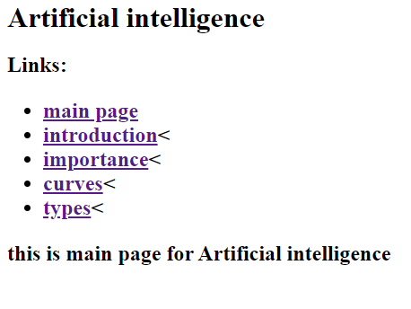

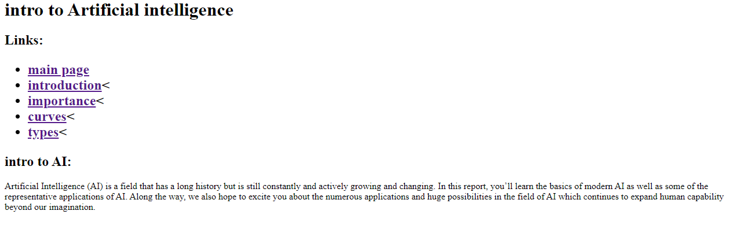

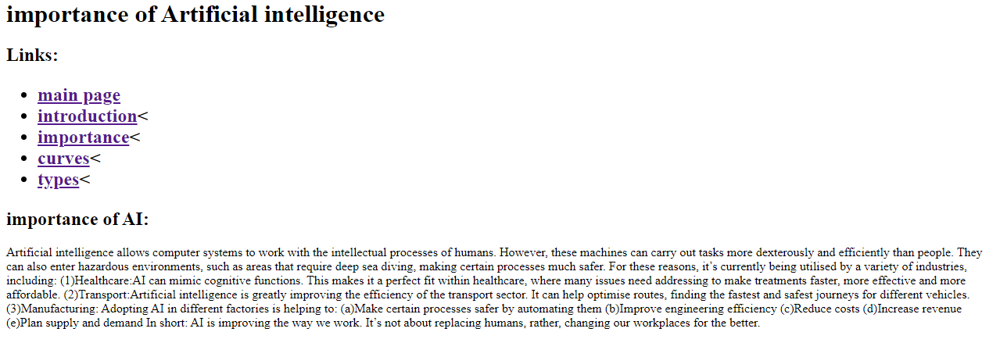

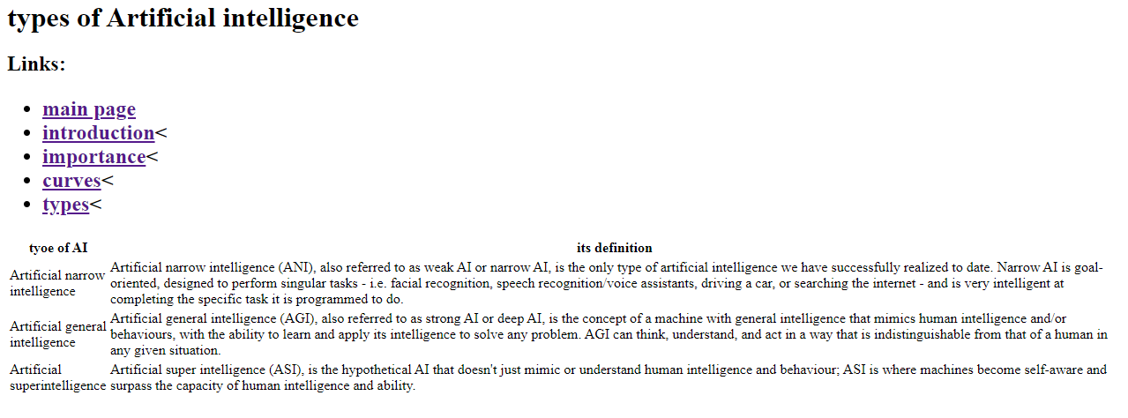

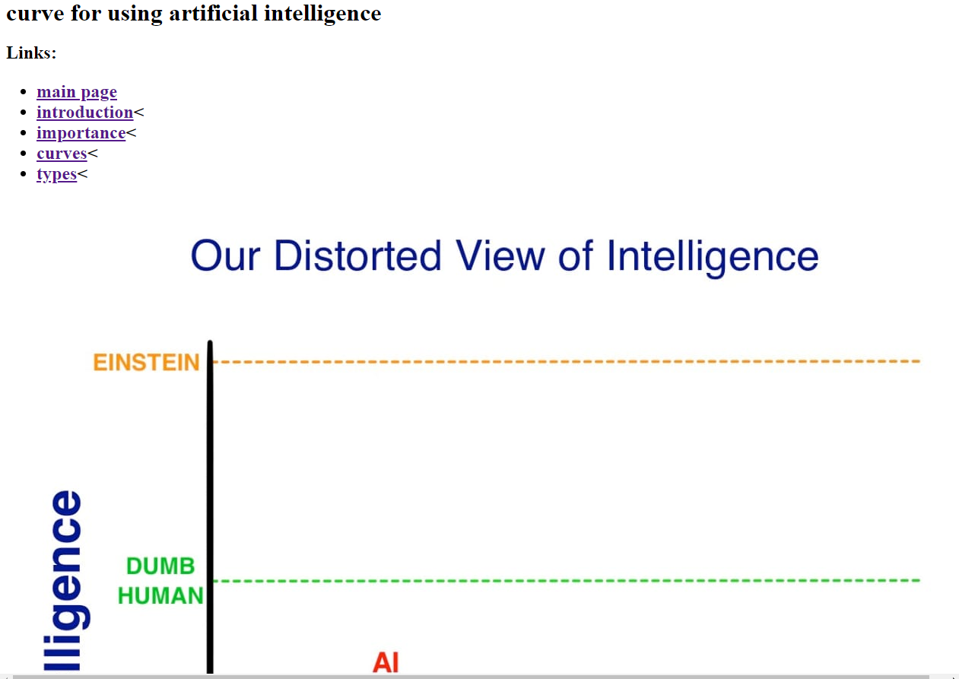

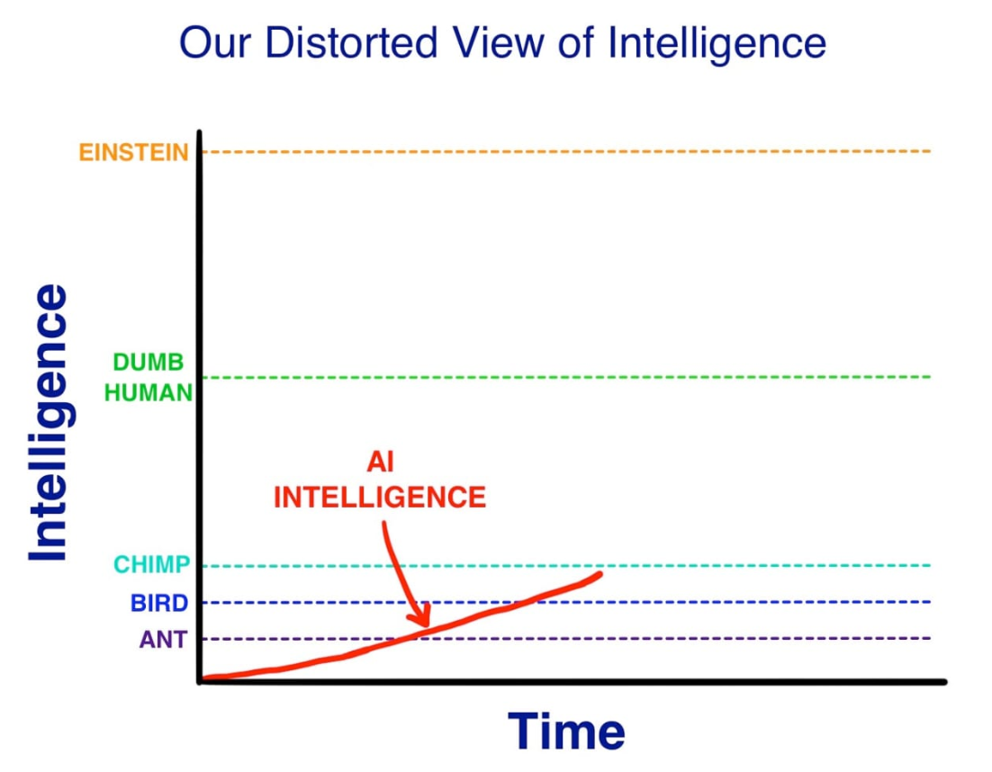

Source Code:

